**VISVESVARAYA TECHNOLOGICAL UNIVERSITY**

Jnanasangama, Macche, Santibastwada Road

Belagavi-590018, Karnataka



**A**

**Mini-Project Report : 21MP110**

on

**Sun Tracking Solar Panel Using Arduino**

*Submitted in partial fulfillment of the requirement for the degree of*

**Bachelor of Engineering – First Year BE (1st Semester)**

*in*

**Electronics & Communication Engineering**

*by*

**USN : 1DS21EC006 ABHINAV SUNDRIYAL**

**USN : 1DS21EC057 CHIRAG VIJAPUR**

**USN : 1DS21EC148 PRATYUSH**

**USN : 1DS21EC029 ANEESH VINOD SAVALGI**

Under the guidance

of

**Dr. Jamuna S**

Professor

ECE Dept., DSCE, Bengaluru



**Department of Electronics & Communication Engineering**

(An Autonomous College affiliated to VTU Belgaum, accredited by NBA & NAAC)

Shavige Malleshwara Hills, Kumaraswamy Layout,

Bengaluru-560078, Karnataka, India

**2021-22**

**Abstract**

During the last few years, the renewable energy sources like solar energy have gained much importance in all over the world. Among the conventional renewable energy sources, solar energy is the most essential and pollution free energy source. Solar energy refers to the conversion of the sun’s rays into useful forms of energy, such as electricity or heat. Different researches estimate that covering 0.16% of the land on earth with 10% efficient solar conversion systems would provide 20 TW of power, nearly twice the world’s consumption rate of fossil energy

Getting solar energy from nature is very beneficial for power generation. Using a fixed solar panel maximum energy can only be extracted during 12 noon to 2 PM in India which results in less energy efficiency.

For maximum output, sun rays must always fall perpendicular to the panel.

**Table of Contents**

Title Sheet i

Certificate ii

Declaration iii

Abstract iv

Table of Contents v

Chapter 1 Introduction 1

Chapter 2 Problem Statement 2

Chapter 3 Methodology 3

Chapter 4 Block diagram and Implementation 4

Chapter 5 Photographs of the model 5

Chapter 6 Results and Discussions 6

Chapter 7 Conclusion 7

References

# CHAPTER 1

# INTRODUCTION

A pollution free, inexhaustible, cheap and reliable source of energy is one of the basic needs. Solar energy is the most apt source taking into account the above conditions. Solar energy also has many limitations which reduces the efficiency.

Orientation of solar radiation changes with respect to the change of seasons, cycle of day-night, latitude, temperature, etc and hence, sun rays are not always perpendicular to the solar panel which reduces the energy production.

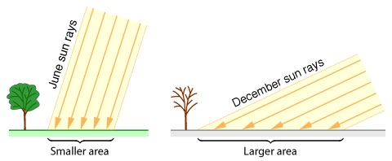

Fig: Solar Orientations in Different Seasons

The diagram shows the change in orientation of sun rays during different seasons. Due to this a typical flat solar panel converts only 40 to 50 percent of incident light into electricity. For maximum output, sun rays must always fall perpendicular to the panel.

Therefore, a sun tracking solar panel is essential to produce maximum energy.

## 

## A solar tracker tracks the maximum intensity of light using LDRs and rotates the panels accordingly to place them perpendicular to the incident light. Hence, maximum power is generated irrespective of seasons and solar orientations.

**CHAPTER 2**

**PROBLEM STATEMENT**

# A traditional solar panel is fixed at a location and generates maximum power only when the sun is directly over it (for limited time).

# Due to continuous rotation of earth and change of seasons the efficiency of solar panel decreases.

An automated system must be built to track solar radiations and rotate the panels accordingly.

# CHAPTER 3

**METHODOLOGY**

The automated sun tracking setup consists :

* 5mm LDRs (x4)
* 6V 100mah (70*70mm) Solar Panel
* Arduino UNO board
* MG 995 Servo Motor (x2)

The LDRs receive the input from the incident sun rays, the data from all the four LDRs is sent to the microcontroller which sends instructions to both the servo motors to rotate in the direction of maximum intensity of solar radiation.

Programming was done in ARDUINO IDE with the knowledge of C language.

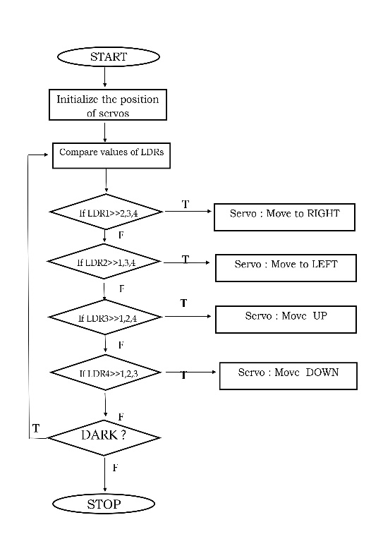

# CHAPTER 4

# BLOCK DIAGRAM AND IMPLEMENTATION

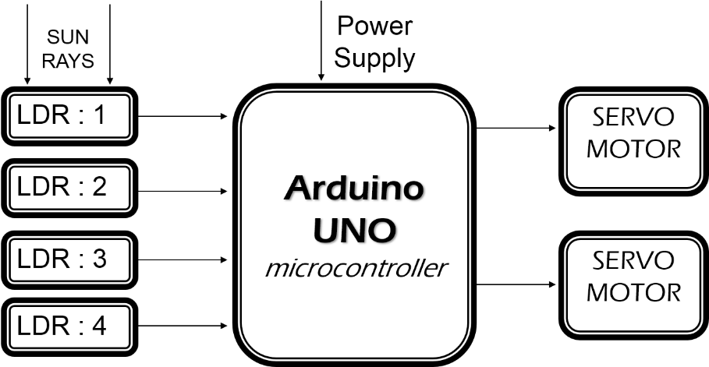

Fig. 1 : Block-diagram of the proposed methodology

All the connections were made according to the circuit below. Solar rays were allowed to incident on the LDRs which sent the data to the microcontroller. Based on the program the microcontroller sent instructions to the servo motors to rotate the setup accurately.

Since, this is a small prototype, we have used an external power source to power the servo motors. In the commercial model the solar panel will produce enough energy to power the motors.

Output of the solar panel was measured and recorded using a multimeter.

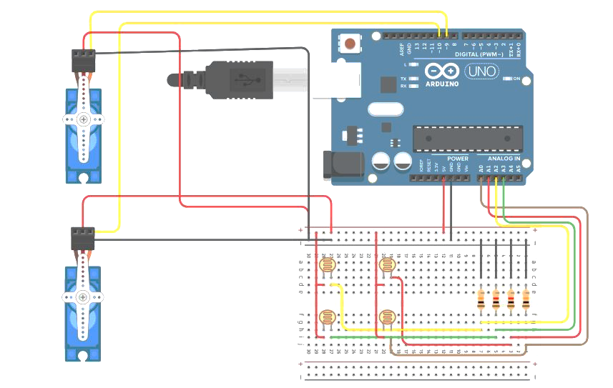

Fig. Circuit of the prototype

# CHAPTER 5

**PHOTOGRAPHS**

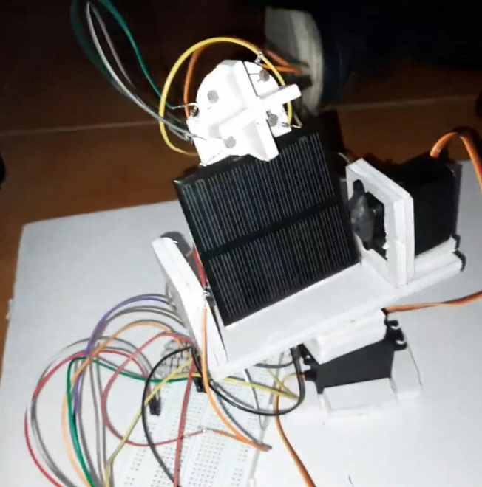 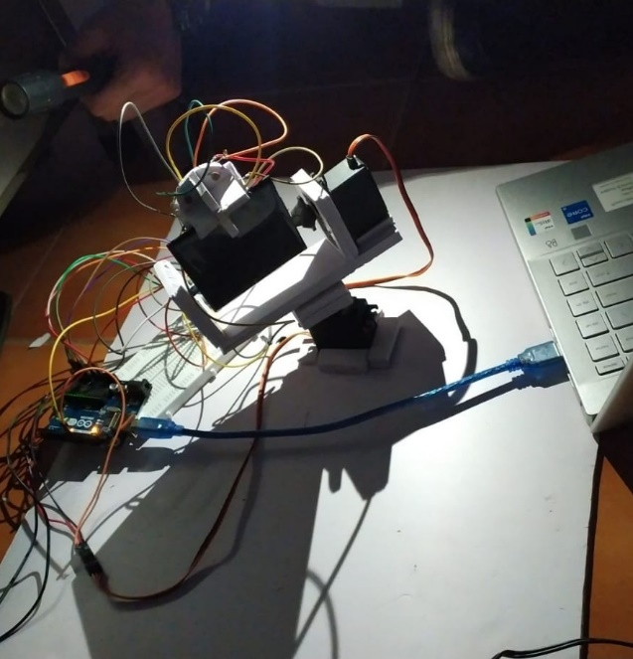

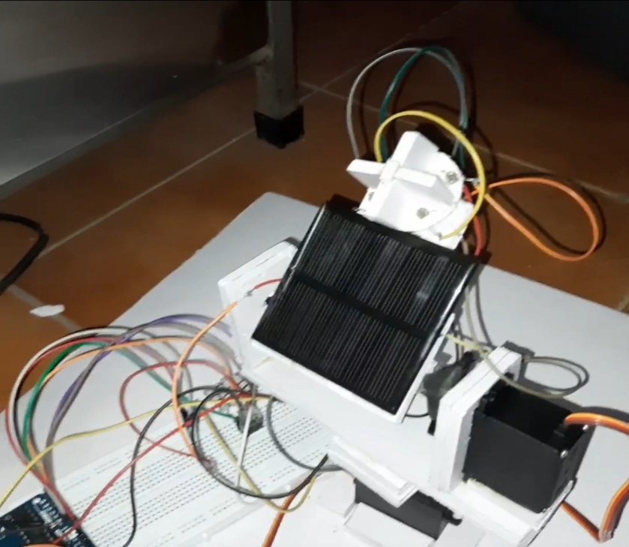

# CHAPTER 6

**RESULTS AND DISCUSSIONS**

Formula for efficiency of Solar Panel :



X 100

Pm is the power produced by the panel = W

E is the irradiance = 1000 W/m2

Ac  is the area of the panel = 0.07m*0.07m = .0049 m2

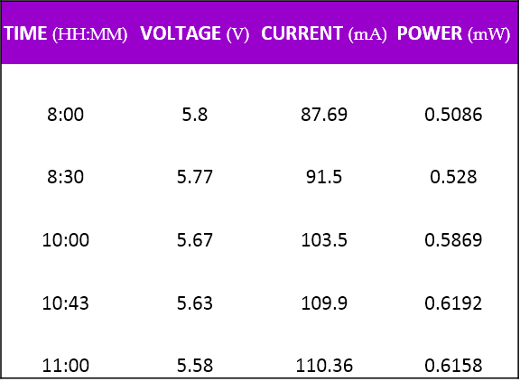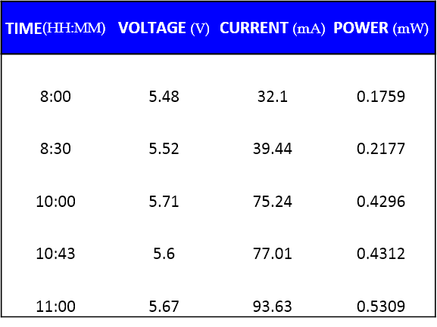

**Data from Solar Tracker**

**Data from Stationary Panel**

* Solar Tracking system showed 12-15% higher efficiency than its stationary counterpart.
* Accurate rotation of the Solar Panel system was achieved in this mini project.

# CHAPTER 7

**CONCLUSION**

ADVANTAGES :

1. Maximum energy production throughout days and seasons
2. On a larger scale 40% more energy production than stationary panels
3. More power generation in lesser space when compared to fixed panels
4. 100% Pollution free and inexhaustible energy source

APPLICATIONS :

1. Space Exploration Vehicles:

This automated system can be installed on exploration rovers. This will produce more energy in the same time due to which rovers can be deployed for a longer period of time.

1. Satellites:

The system can also be installed on satellites. This will produce power even when there are lesser rays falling due to obstruction by planets. Deployment time of satellites can be increased.

1. Solar Vehicle Charging:

The setup can be installed on the roof of vehicles. Once the vehicle is set in charging mode, the panels will automatically come out and rotate in the direction where maximum intensity of light falls.

The vehicle will even charge when there is an obstruction by buildings or trees.

LIMITATIONS:

1. Trackers require more maintenance than fixed systems.
2. Solar trackers are built for climates where there is little to no snow, making them a more realistic option in warmer climates
3. These may appear to be quite expensive for single household usage
4. A small fraction of produced energy is utilized by the motors for rotation

**REFERENCES**

Books :

[1]. Khyati Vyas, “Guide for Solar Tracking System: Design & Development of prototype for SPV Tracking System”, LAP LAMBERT Academic Publishing, India, ISBN-10 ‏: ‎ 6202009896, 1st edition, August 2017

# Conferences :

## [1]. Dr.N.Agya Utama Utama, Dr.Benjamin C. McLellan,  Dr.Hagus Tarno,  Dr.Hagus Tarno,  Dr.Suharman Hamzah, “Power Feasibility of a Low Power Consumption Solar Tracker”,*Sustainable Future for Human Security, Japan,*  ISSN: 1878-0296, Nov 05, 2012

Websites :

[1]. <https://www.solarpowerworldonline.com/2020/01/what-is-a-solar-tracker-and-how-does-it-work/>

[2]. <https://create.arduino.cc/projecthub/akshayjoseph666/servo-motor-interface-with-arduino-uno-9693ad>

[3]. <https://sinovoltaics.com/learning-center/csp/solar-tracker/>

[4]. <https://www.researchgate.net/figure/The-design-concept-of-the-proposed-solar-tracker_fig1_320441420>